
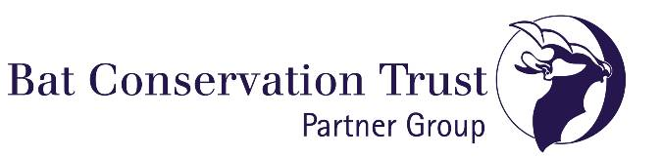

The South Yorkshire bat group works to furthering the study and conservation of bats in South Yorkshire. To achieve this we have the following objectives:
- Develop a database of bat records for the South Yorkshire region.
- Increase the number of Natural England volunteer bat workers.
- Provide training for group members to increase the skills and knowledge of those interested in studying bats in South Yorkshire.
- Support projects suggested by bat group members.
- Assist local planning authorities, government bodies, charities and other organisations wherever possible in matters relating to bats.
- Provide talks, walks, and presentations to members of the public.
- Hold meetings and events throughout the year for members in training, roost visits, hibernation checks, and participation in the national bat monitoring scheme.
You can help the bats in South Yorkshire by joining the South Yorkshire bat group

Indoor meetings are held at various locations, mainly in Sheffield. Forthcoming events are listed on South Yorkshire Bat Group’s Google Group where you can view past projects, events, surveys etc and participate in discussion about what is coming up, what aspects of bats you are interested in and how you would like to help.

Membership of SYBG is £10 per year. A reduced rate of £5 is available for members who are not currently working/students/OAP etc. If you join towards the end of the year your membership will be carried over to the next one.

You can complete this form electronically and email back to sybatgroup@googlemail.com and pay your membership either by cheque to the address below or via electronic transfer/BACS etc (please include your name on your electronic payment).

South Yorkshire Bat Group (The Co-operative bank)
Sort code: 08-92-99 Account Number: 65716672
If you prefer to pay by cheque, please can you make out cheques to “South Yorkshire Bat Group” and send to the following address:
Simon Michie,
Treasurer - South Yorkshire Bat Group,
8 Herbert Road,
Sheffield, S7 1RL

Membership Application Form
Name: |  |  |  | Date:
Address: |  | Email:
 |  | Phone Number:
 |  | Date Of birth:
 |  | Occupation:
Level of membership required:
Employed |  |  | Student/Unemployed/OAP
Do you have any mobility or other concerns that may affect your ability to participate in field visits or field survey work (if yes please give details)?
Experience of Bat Conservation and Survey (please mark where appropriate)
Interested but know little about bats |  |  | Able to use bat detector
Some knowledge of bats |  |  | Licensed bat worker
Use of bat detector
Have you been vaccinated against rabies?
Equipment Owned
Bat Detector |  |  | Bat detector type:
Torch |  |  | Head Torch
Mini disc / MP3 recorder |  |  | Other:
Interests/Expectations as a Member:
To learn more about bats |  |  | Community involvement
Bat husbandry |  |  | Organisation
Obtain roost visitor license |  |  | Social/occasional involvement
 |  |  | Teaching/education
Teaching/education
Intended contribution to the group
Fund raising |  |  | Roost visits
Publicity |  |  | Research
Committee member |  |  | Survey
Other Comments:

Membership details are only held by the group and will not be given to any other organisations, groups or individuals.

